

WinMan REST API – Internal Developers’ Guide
Version: 2.0.0 By Lynn Eagleton

WinMan REST API
Contents
Overview 3
Prerequisites 4
System Prerequisites 4
Installation for Development (Standard API) 5
Installing the global Node modules 5
Adding the environment variables 5
Cloning the repository 6
Installing the API 6
Adding an entry in your hosts file 8
Adding the Windows service 8
Activating the UI Screens 9
Activating the REST API Scopes 9
Development (Standard API) 12
Using Git 12
Creating a new endpoint 23
Creating a new release 32
Installation for a Customer (Standard API) 35
Installation for Development (Bespoke API) 38
Installing the global Node modules 38
Adding the environment variables 38
Cloning the repository 39
Installing the API 40
Adding an entry in your hosts file 41
Adding the Windows service 41
Development (Bespoke API) 43
Using Git 43
Creating a new endpoint 45
Installation for a Customer (Bespoke API) 46
Upgrading a Customer (Standard API and Bespoke API) 47
NPM commands 48
Build 48
Compile 48
Develop 49
Sass 49
Further reading 50

Overview

The WinMan REST API makes it possible for developers to integrate web-based systems with WinMan. The API makes WinMan data accessible over HTTPS using OAUTH2 authentication/authorisation, keeping data secure. It can provide and accept both JSON and XML formatted data.
The current version of the API is geared towards eCommerce website integration, and as such, the endpoints which are available allow developers to retrieve data for:
- Products.
- Products Attachments (e.g. image and PDFs).
- Product Stock Levels.
- Product Categories.
- Customers.
- Price Lists.
- Customer Delivery Addresses.
- Customer Sales Orders.
- Customer Sales Invoices.
- Customer Statements,
- Customer Account Overviews.
Developers can also send data back to WinMan for:
- New Sales Orders.
- New Customers.
- Converting a Quote to a Sales Order.
Endpoints can be purchased separately.
A single installation of the WinMan REST API allows developers to communicate with a single Live and a single Training database. If more than one Live/Training database exists, multiple installations of the WinMan REST API will be required to communicate with them. This is covered in more detail in the Prerequisites section of this document.
If the customer’s databases are for different versions of WinMan, separate installations of the WinMan REST API should be installed for each database, otherwise, the API may behave unexpectedly due to incompatibilities between the databases and the API codebase.
This document includes several code snippets and commands. Please note that all commands / code snippets in this document are case-sensitive. It is recommended that you read through this document thoroughly, in its entirety, before attempting to carry out any work with the API.
This document covers version 2.0.0 of the WinMan REST API.

Prerequisites

System Prerequisites

In order to install a development version of the WinMan REST API v2.0.0 the following conditions must be met on your PC.
- WinMan v7.0098.31. The WinMan application does not have to be installed on your PC, but you must be able to access to the database from your PC. This guide assumes your will be using your development WinMan application on SQL2016SANDBOX.
- NodeJS v6.11.2. More recent versions of NodeJS may be compatible but have not yet been tested.
- Git Bash. This guide uses Git Bash for all version control related operations. You may use other applications if you wish (e.g. Git Kraken).
- Access to the WinMan REST API Git repository. Access to this repository in GitHub is controlled by Stu.

A single installation of the WinMan REST API gives developers access to data from one Live and one Training WinMan application. This runs as a Windows Service and is typically made accessible via port 3000. The Windows Service name should be similar to winman-rest-api.
You can install the API as many times as you like to access additional WinMan applications. Subsequent installations of the API should typically be made available via sequential ports, and the Windows Service names should be appended with some unique identifier (e.g. winman-rest-api-usa, winman-rest-api-eu etc.).

Installation for Development (Standard API)

Installing the global Node modules
This guide assumes that you have already installed NodeJS v6.11.2 on your PC. Please note that all commands / code snippets in this document are case-sensitive.
If you have not installed any version of the WinMan REST API on your PC before, you will need to install two global Node modules. If you have already installed these two modules, you can skip this step, otherwise, open an elevated command prompt window (right-click and click Run as Administrator), type the following and hit enter.
npm install --global --production windows-build-tools
This command will take approximately 5-10 minutes to complete. After it has completed, type the following and press enter.
npm install --global node-gyp
This command will take approximately 1-2 minutes to complete.

Adding the environment variables

If you have not installed any version the WinMan REST API on your PC before, you will need to create two new environment variables. If you have already done this, you can skip this step, otherwise, open the System Environment Variables window. To do this, click the Windows button in the bottom-left corner of the screen and type environment variables. Click on the result labelled Edit the system environment variables, which will bring up a small properties window. In this window, click the button labelled Environment Variables. You should now see a window similar to the following:

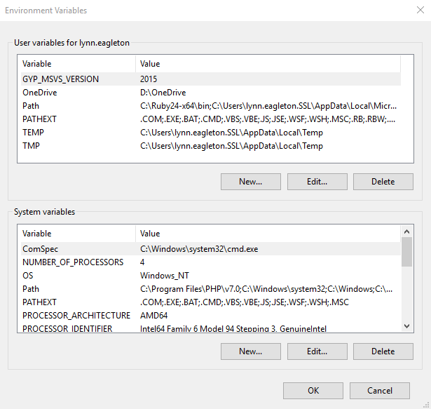
Click the bottom button labelled New… to create a new system environment variable.

There are two variables to create, the first of which defines the location of the Python executable. You should enter the following information and click OK when done:

Variable name: PYTHON
Variable value: C:\Users\<username>\.windows-build-tools\python27\python.exe

You should change <username> to match the user you log on to your PC with, for example lynn.eagleton.SSL.

The second variable defines the mode which NodeJS runs in on your PC. You should enter the following information and click OK when done:

Variable name: NODE_ENV
Variable value: development

Next, you should close and reopen your elevated command prompt window so that the new environment variables take effect.

Cloning the repository
To install the WinMan REST API, you must first clone the WinMan REST API repository from GitHub. If you do not have access to this repository, please speak to Stu to request access.
This guide assumes you are using Git Bash for version control operations.
To clone the repository, open a file explorer window, navigate to an appropriate location on your PC (e.g. D:\git), right-click in this window and then click Git Bash Here. This opens the Git Bash application. Type the following and hit enter.
git clone https://github.com/WinMan-Birmingham/winman-rest-api.git
You will be prompted for your GitHub username and password. Enter your credentials to continue the clone. After this has completed, you can return to your elevated command prompt window.

Installing the API

In your elevated command prompt window type the following and press enter.
cd /d "<path to git>\winman-rest-api"
You should replace <path to git> with the file path you used to clone the repository (e.g. D:\git).

Next, type the following and press enter.
npm install
This may take 5-10 minutes to complete.

Once this has completed, you must generate your development config file. To do this, type the following and press enter.
npm run develop
You will be prompted for several pieces of information. For each question that is presented, you can enter ? if you wish to view a help message. If you accidentally enter the wrong information, you will need to manually edit the generated index.js file in the config folder or re-run the above command and enter the information again. For development on your local PC using your SQL2016SANDBOX WinMan application, you may wish to use settings like the following.

Service name: winman-rest
Service display name: WinMan REST API
Live SQL server name: SQL2016SANDBOX
Live SQL server instance name: <leave blank>
Live SQL server username: winman
Live SQL server password: winman
Live SQL server database name: <your DB name>
Live reports server username: <the username you use to log on to your PC>
Live reports server password: <the password you use to log on to your PC. Please note that the password is masked on the screen as you type it and encrypted in your config file, so you don’t need to worry about others seeing it>
Would you like to add a Training system? N
API URL: rest.winman.net
API port: 3000

Finally, you must generate the necessary frontend files. To do this, type the following and press enter.
npm run compile
The above command lints and compiles all Sass files into CSS, minifies and obfuscates template files and JavaScript files, and copies these files into the necessary places within your WinMan REST API repository directory.

Adding an entry in your hosts file

To be able to access your API, you must add an entry to your PC’s hosts file. To do this, open a text editor like Notepad as an Administrator and open the following file.
C:\Windows\System32\drivers\etc\hosts
Add the following to the bottom of the.
127.0.0.1 rest.winman.net
You should change rest.winman.net to match the API URL you used whilst generating your development config file.

Adding the Windows service

In order for the API to be available all the time, it needs to be run as a Windows service. To set this up, back in your elevated command prompt window, type the following and press enter. Please note that you must run this command from your WinMan REST API repository directory. cd to the correct directory if necessary (see the first command in the Installing the API section of this document).
node winman-rest --add
If the service is added successfully, you should see a message which says something like WinMan REST API service successfully added.

Finally, you can start the service. Type the following and press enter.
net start "<service name>"
You should replace <service name> with the actual service name, e.g. winman-rest.
If the service is started successfully, you should see a message which says something like The WinMan REST API service was started successfully.

The API is now installed, but before you can access any information, some data must be added within the WinMan application. Instructions on what to add and how to add it can be found in the WinMan REST API v2.0.0 User Manual.

Also, the relevant programs and REST API Scopes in WinMan must be activated. The next two sections of this document explain how to achieve this.

Activating the UI Screens
After installing the API, you should ensure that the necessary programs are enabled in the WinMan application, namely Rest API Users and Ecommerce Websites. These two programs are disabled by default, so if either of these programs do not appear in WinMan when you search for them, you will need to manually activate them in the database.
To do this, run the following query on your database.
UPDATE
Programs
SET
Display = 1
WHERE
Program IN ('EcommerceWebsites', 'RestAPIUsers');

Activating the REST API Scopes
REST API Scopes can be thought of as permissions. For example, the scope getCustomers allows developers to fetch customer data from WinMan to use on a website, and the scope postSalesOrders allows developers to send new sales order data back in to WinMan from a website.
REST API Scopes match up to endpoints which can be purchased separately, so they are not included in the WinMan database as part of a patch or major release and instead must be added manually upon installation.
The SQL query below can be used to add all the scopes which are currently available in the standard version of the API.
IF NOT EXISTS(SELECT RestApiScope FROM RestApiScopes WHERE RestApiScopeId = 'getCustomerPriceLists')
BEGIN
INSERT INTO RestApiScopes (RestApiScopeId, [Description]) VALUES ('getCustomerPriceLists', 'allows read access to customer price lists');
END;
IF NOT EXISTS(SELECT RestApiScope FROM RestApiScopes WHERE RestApiScopeId = 'getCustomers')
BEGIN
INSERT INTO RestApiScopes (RestApiScopeId, [Description]) VALUES ('getCustomers', 'allows read access to customers');
END;
IF NOT EXISTS(SELECT RestApiScope FROM RestApiScopes WHERE RestApiScopeId = 'postCustomers')
BEGIN
INSERT INTO RestApiScopes (RestApiScopeId, [Description]) VALUES ('postCustomers', 'allows write access to new customers');
END;
IF NOT EXISTS(SELECT RestApiScope FROM RestApiScopes WHERE RestApiScopeId = 'getProductAttachments')
BEGIN
INSERT INTO RestApiScopes (RestApiScopeId, [Description]) VALUES ('getProductAttachments', 'allows read access to product attachments');
END;
IF NOT EXISTS(SELECT RestApiScope FROM RestApiScopes WHERE RestApiScopeId = 'getProductCategories')
BEGIN
INSERT INTO RestApiScopes (RestApiScopeId, [Description]) VALUES ('getProductCategories', 'allows read access to product categories');
END;
IF NOT EXISTS(SELECT RestApiScope FROM RestApiScopes WHERE RestApiScopeId = 'getProductInventories')
BEGIN
INSERT INTO RestApiScopes (RestApiScopeId, [Description]) VALUES ('getProductInventories', 'allows read access to product inventories');
END;
IF NOT EXISTS(SELECT RestApiScope FROM RestApiScopes WHERE RestApiScopeId = 'getProducts')
BEGIN
INSERT INTO RestApiScopes (RestApiScopeId, [Description]) VALUES ('getProducts', 'allows read access to products');
END;
IF NOT EXISTS(SELECT RestApiScope FROM RestApiScopes WHERE RestApiScopeId = 'postSalesOrders')
BEGIN
INSERT INTO RestApiScopes (RestApiScopeId, [Description]) VALUES ('postSalesOrders', 'allows write access to new sales orders');
END;
IF NOT EXISTS(SELECT RestApiScope FROM RestApiScopes WHERE RestApiScopeId = 'getDeliveryAddresses')
BEGIN
INSERT INTO RestApiScopes (RestApiScopeId, [Description]) VALUES ('getDeliveryAddresses', 'allows read access to customer delivery addresses');
END;
IF NOT EXISTS(SELECT RestApiScope FROM RestApiScopes WHERE RestApiScopeId = 'getSalesOrders')
BEGIN
INSERT INTO RestApiScopes (RestApiScopeId, [Description]) VALUES ('getSalesOrders', 'allows read access to sales orders');
END;
IF NOT EXISTS(SELECT RestApiScope FROM RestApiScopes WHERE RestApiScopeId = 'getAccountOverviews')
BEGIN
INSERT INTO RestApiScopes (RestApiScopeId, [Description]) VALUES ('getAccountOverviews', 'allows read access to customer account overview information');
END;
IF NOT EXISTS(SELECT RestApiScope FROM RestApiScopes WHERE RestApiScopeId = 'getStatements')
BEGIN
INSERT INTO RestApiScopes (RestApiScopeId, [Description]) VALUES ('getStatements', 'allows read access to customer statements');
END;
IF NOT EXISTS(SELECT RestApiScope FROM RestApiScopes WHERE RestApiScopeId = 'getInvoices')
BEGIN
INSERT INTO RestApiScopes (RestApiScopeId, [Description]) VALUES ('getInvoices', 'allows read access to customer invoices');
END;
IF NOT EXISTS(SELECT RestApiScope FROM RestApiScopes WHERE RestApiScopeId = 'getPdfs')
BEGIN
INSERT INTO RestApiScopes (RestApiScopeId, [Description]) VALUES ('getPdfs', 'allows read access to PDF printouts');
END;
IF NOT EXISTS(SELECT RestApiScope FROM RestApiScopes WHERE RestApiScopeId = 'putConvertQuotes')
BEGIN
INSERT INTO RestApiScopes (RestApiScopeId, [Description]) VALUES ('putConvertQuotes', 'allows write access to convert quotes to orders');
END;
Once the scopes have been added to the database, they can be assigned to eCommerce Websites to enable you to start using the API. Instructions on how to do this can be found in the WinMan REST API v2.0.0 User Manual.
Once all the installation steps have been completed, you should be able to access the login screen of your development API in a web browser. Please note that the API is only available over HTTPS, not HTTP, so you will need to navigate to (for example) https://rest.winman.net:3000. You should change this URL to match the API URL and API port you used whilst generating your development config file.

Development (Standard API)

Using Git

Creating a new branch
All development work for the WinMan REST API must be carried out on your own branch in Git. You must never commit directly to the master branch, as this can cause problems for other developers who are also contributing to the project.
To create your own branch, open Git Bash from within your WinMan REST API repository directory and make sure you have the master branch checked out. You will know you have the master branch checked out if you can see (master) at the end of the file path in Git Bash, for example:
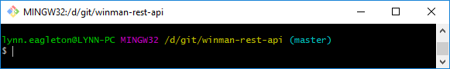
You can also check which branch you’re currently on by issuing the git status command, for example:
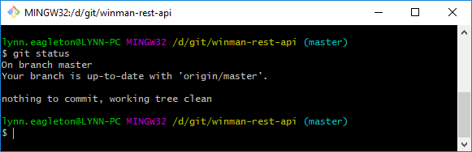
Make sure you have the latest version of the master branch by issuing the following command.
git pull
Next, create your branch by issuing the following command.
git checkout -b <branch name>
You should use an informative branch name so that it is clear what the branch is for. For example, if your task is to create a new endpoint called Hello World, you should use a branch name like create-hello-world-endpoint. Please note that branch names cannot contain spaces.
The first time you attempt to push your new branch to the remote repository in GitHub using the git push command, you will see a message like the following.
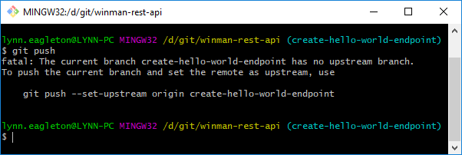
This is because your branch does not currently exist in the remote repository, so Git is unable to determine where to push your commits to. To resolve this, we must do as Git suggests and issue the following command.
git push --set-upstream origin <branch name>
If all goes well, you will see something like the following.
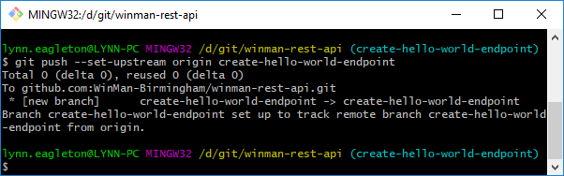
Now that your new branch is created, you can begin your development work.

Creating commits
Every time you complete a significant portion of development work, you should create a new commit on your branch. It is bad practice to simply create one huge commit at the very end of your task, so you should get into the habit of adding each piece of functionality as a separate commit. To do this, you must first stage your changes by using the git add command, or by using the appropriate buttons in whichever IDE you are using.
To use the git add command to stage a single file, use the following.
git add <relative path to file>
To use the git add command to stage all changed files simultaneously, use the following (the . is not a typo, please include it!).
git add .
To verify that your files have been staged, you can use the git status command. In Git Bash, staged changes will display in green and unstaged changes will display in red. For example:
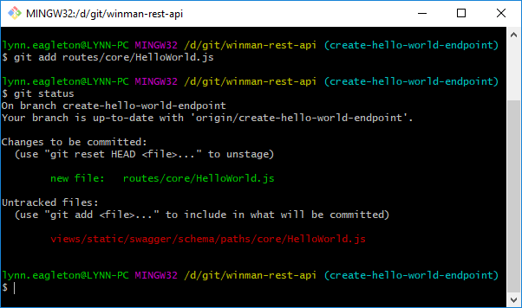
Once you are happy that you have staged the correct files, issue the following command.
git commit
This will display a vim editor in which you can type your commit message. You should structure your commit message with a heading on the first line which ends with the WinMan case number (if applicable), followed by some bullet points detailing the work you are committing. To begin typing in the vim editor, you first need to press i on your keyboard to enter insert mode. All lines beginning with # are considered commented out and are ignored in your commit message. For example:
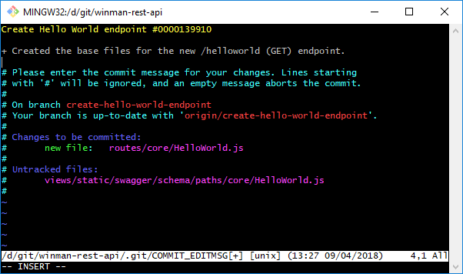
Once you are happy with your commit message, press the Esc key on your keyboard to exit insert mode, then type :wq and hit enter. This saves your changes and exits the editor. For more information on using the vim editor, visit this link.
To verify that your commit has been created successfully, use the git log command to view the Git log. You should see something like this:
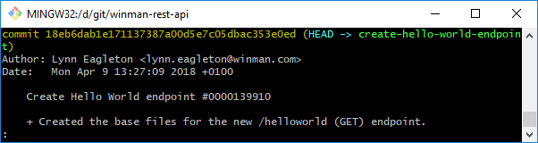
To exit the Git log, simply press q on your keyboard.
Once you are happy with your changes and you wish to push your commit to the remote repository, issue the following command.
git push

Creating pull requests
Once you have completed your work, you should create a pull request in GitHub so that other developers can review and approve your changes. To do this, ensure you have pushed all your work up to the remote repository in GitHub, then visit the WinMan REST API repository in GitHub in a web browser.
Click on the Branch drop-down menu and click on your branch:
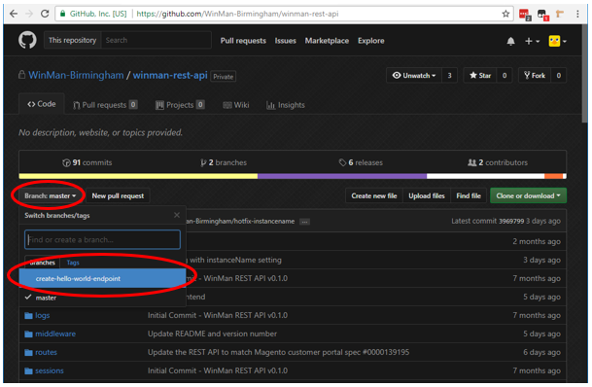
Next, click on New pull request:
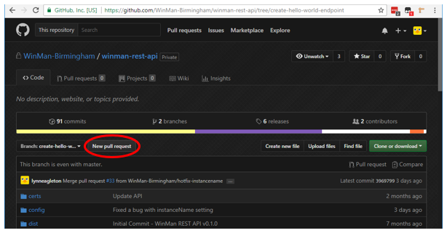
Enter an appropriate title and description for your pull request. If your pull request contains only one commit, the title and description boxes will be automatically populated based on your commit message. You should also check to make sure the commits listed underneath the description box are the commits you are expecting to see:
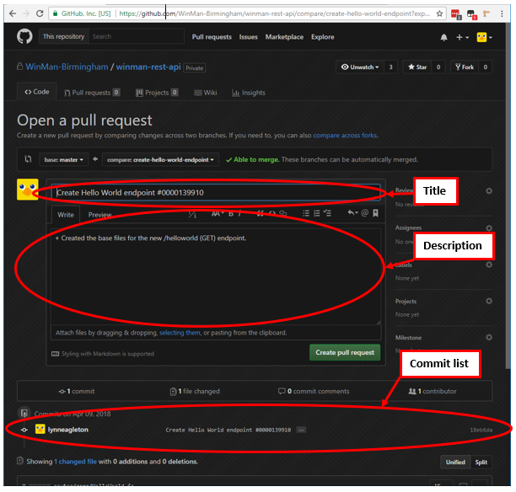
Once you are happy, click the green Create pull request button.

Reviewing pull requests
If you need to review a pull request, you will find the list of currently open pull requests it in the Pull requests tab within the repository in GitHub:
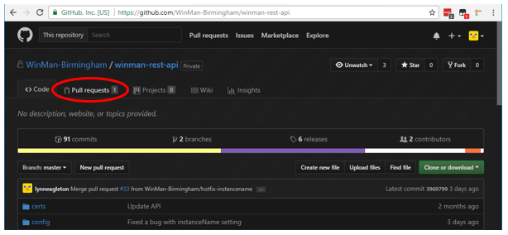
Click on the pull request you need to review then click on the Files changed tab to view the changes:
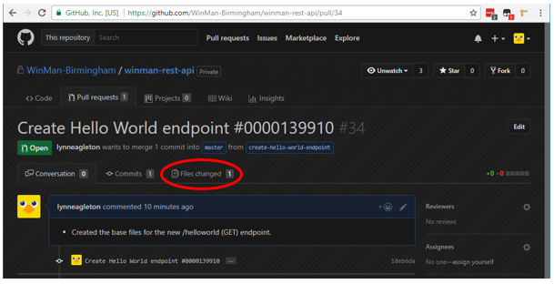

If you are happy to approve the changes, click the Review changes button (top-right of the screen), check the Approve radio button in the box that appears, enter a comment in the comments box (optional) and click Submit review. This will take you back to the Conversation tab of the pull request, where you can optionally add additional general comments:
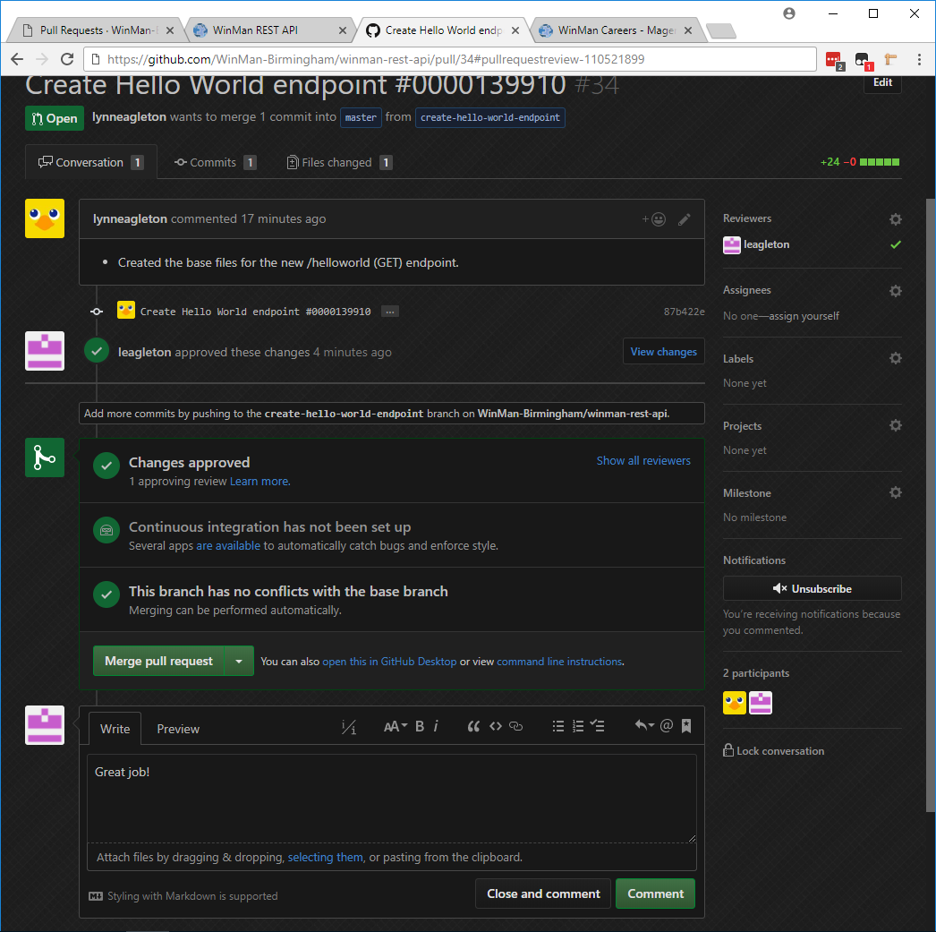

If you need to make comments requesting changes, you can hover your cursor next to the relevant line number and then click the blue + button that appears. This will open a comments box where you can type your comments:
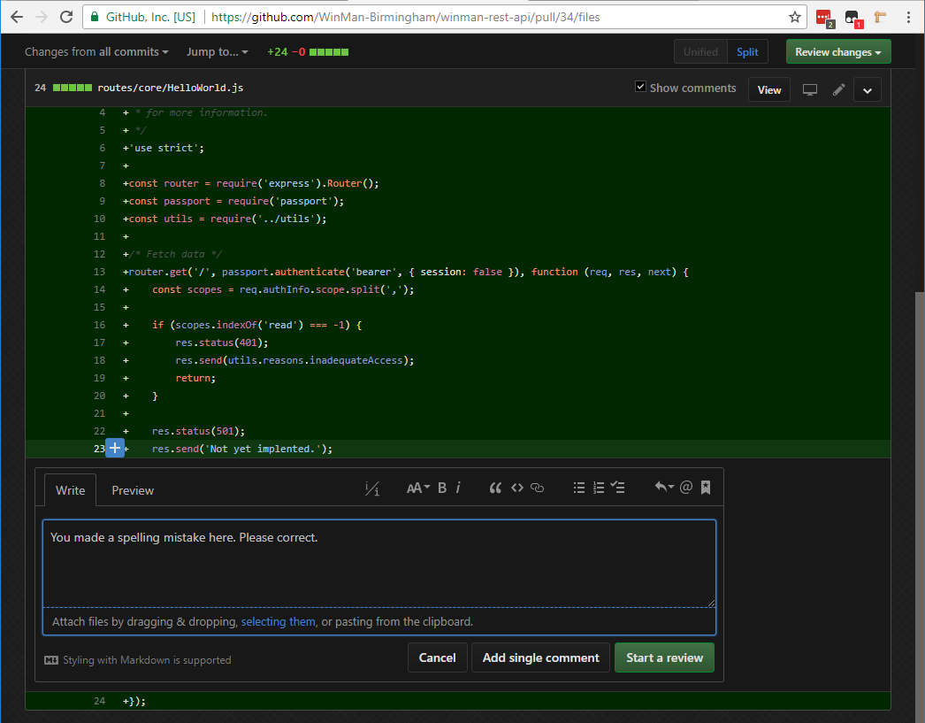
When you have finished your comment, click the Start a review button to move on. For subsequent comments, the button will say Add review comment instead of Start a review. You can add as many comments as you like on whichever line numbers you like.

Once you have added all your comments, click the Review changes button (top-right of the screen), check the Request changes radio button in the box that appears, enter a comment in the comments box (optional) and click Submit review. This will take you back to the Conversation tab of the pull request, where you can optionally add additional general comments:
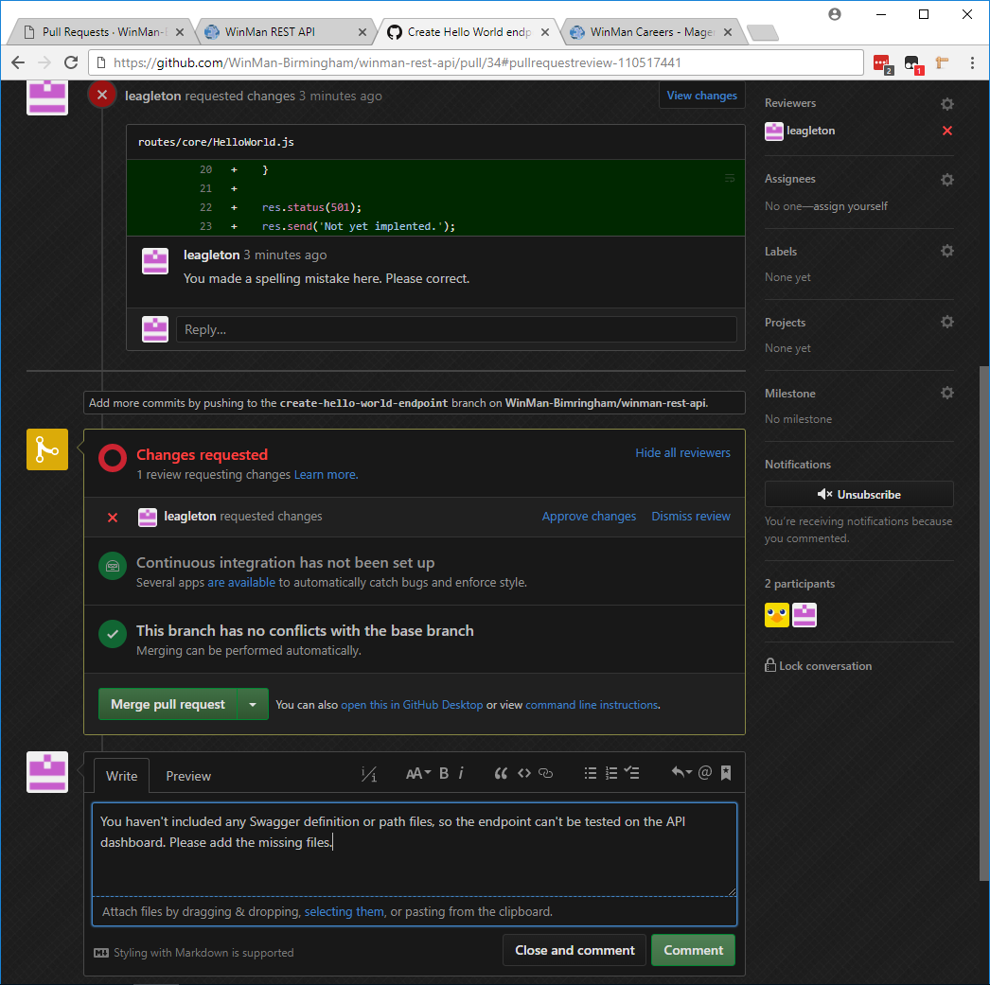

Merging pull requests
When your pull request has been approved you are ready to merge it into the master branch. To do this, navigate to the pull request in GitHub and click the green Merge pull request button. You can then optionally add additional comments in the comments box that appears, then click the green Confirm merge button when ready to continue.
Once merged, you will see a confirmation message and a Delete branch button:
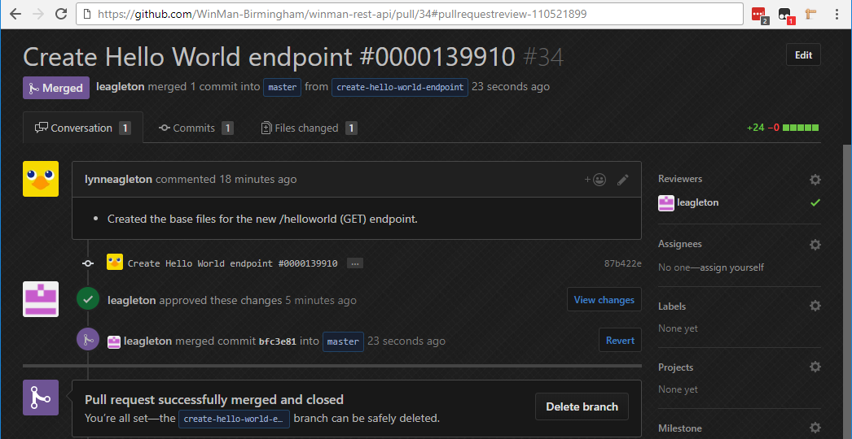
You should click the Delete branch button to delete your branch from the repository in GitHub. This ensures that the repository doesn’t become cluttered with old, unnecessary branches.
You should also delete the branch from your local repository on your PC for the same reason. To do this, open Git Bash from within your WinMan REST API repository directory and make sure you have the master branch checked out. If you need to need to switch branch, use the following command:
git checkout master
It is advisable to make sure you have the latest version of the master branch at this point. Issue the following command:
git pull
Now you can delete the unnecessary branch with the following command:
git branch -D <branch name>

Creating a new endpoint
This section of the guide runs through the basics of creating a brand new endpoint for the standard WinMan REST API. For bespoke endpoints, please see the appropriate section of this document.
Assuming we wish to create a basic GET endpoint (/helloworld) which produces either JSON or XML, we would need to create the following files:
├── routes
│ └── core
│ └── HelloWorld.js
├── sql
│ └── stored_procedures
│ ├── wsp_RestApiHelloWorldSelectJSON.sql
│ └── wsp_RestApiHelloWorldSelectXML.sql
└── views
└── static
└── swagger
└── schema
├── definitions
│ └── core
│ └── HelloWorld.json
└── paths
└── core
└── HelloWorldMessage.json

The route file
The most important file here is routes/core/HelloWorld.js , because this is the file which actually contains the endpoint code. The file must be named with the same name as the endpoint itself. For example, to create an endpoint which is available at /myendpoint , you should name your file MyEndpoint.js .
Let’s assume our Hello World endpoint accepts one parameter: website. Let’s also assume that this endpoint uses the getProducts scope and falls under the Products category on the API dashboard. Our route file should look as follows. Code comments have been added to explain the code. You can omit these comments in your development work if you wish.
/**
* Enable strict mode. See:
* https://developer.mozilla.org/en-US/docs/Web/JavaScript/Reference/Strict_mode
* for more information.
*/
'use strict';
/**
* Initialise required node modules. Similar to
* 'Imports <namespace>' statements in VB.NET.
*
* 'router' is used for routing, i.e. determining which URL goes where.
* 'passport' is used for authentication.
* 'utils' refers to our custom functions for handling SQL queries and responses.
*/
const router = require('express').Router();
const passport = require('passport');
const utils = require('../utils');
/**
* GET a Hello World message.
*/
router.get('/', passport.authenticate('bearer', { session: false }), function (req, res, next) {
/**
* This array will contain the parameters which will be fed into
* the stored procedure.
*/
const inputParams = [];
/**
* We need to check the scopes which have been fed into the request
* to make sure the client has permission to use the correct scope
* for this endpoint. If not, return a 403 (Forbidden) error.
*
* If the client does have permission, we need to feed the scope
* into the stored procedure so we can check that the scope is
* enabled for the eCommerce website in WinMan.
*/
const scopes = req.authInfo.scope.split(',');
if (scopes.indexOf('getProducts') === -1) {
res.status(403);
res.send(utils.reasons.inadequateAccess);
return;
} else {
inputParams.push("@scope = 'getProducts'");
}
/**
* 'Website' is always a required parameter for any endpoint
* in the WinMan REST API because it is used to verify the authenticity
* of access tokens. Check to make sure the parameter has been supplied.
* If not, return an error. If so, add it to the parameters to feed
* into the stored procedure.
*/
if (typeof res.locals.website !== 'undefined') {
inputParams.push("@website = '" + res.locals.website + "'");
} else {
return utils.reject(res, req, utils.reasons.requiredParam);
}
/**
* Here we define the name of the stored procedure to run.
* You must leave 'JSON' and 'XML' off the end of the name here,
* as the functions elsewhere in the API codebase handle
* which version to use.
*/
sp: "wsp_RestApiHelloWorldSelect",
args: inputParams
};
/**
* Finally, execute the stored procedure and return
* the results.
*/
return utils.executeSelect(res, req, params);
});
/**
* This line is required so that the .get() function
* above is available for other files in the API codebase
* to invoke.
*/
module.exports = router;

The stored procedures
You should commit your stored procedures to the repository along with the other files in the form of a .sql file. For GET endpoints, you require at least two stored procedures: one ending with ‘JSON’ and the other ending with ‘XML’. This is because the API can produce both JSON and XML output depending on the request received.
Your stored procedures should use the naming convention wsp_RestApi<purpose of procedure>, and each stored procedure should be included in your commits in a separate file named wsp_RestApi<purpose of procedure>.sql. In our Hello World example, we’re using wsp_RestApiHelloWorldSelectJSON and wsp_RestApiHelloWorldSelectXML.
Because we need to support older versions of SQL Server, we must manually create our JSON output using the STUFF function. The stored procedure below will produce the following JSON.
JSON produced:
{
"HelloWorldMessages": [{
"Message": "Hello World!"
}]
}
WinMan REST API stored procedure:
SET ANSI_NULLS ON;
GO
SET QUOTED_IDENTIFIER ON;
GO
SET TRANSACTION ISOLATION LEVEL READ UNCOMMITTED;
GO
BEGIN TRANSACTION AlterProcedure;
-- =============================================
-- Author: Lynn Eagleton
-- Create date: 10 April 2018
-- Description: Stored procedure for SELECTing a simple
-- Hello World message for the WinMan REST API in JSON format.
-- =============================================
IF NOT EXISTS
(
SELECT
p.[name]
FROM
sys.procedures p
INNER JOIN sys.schemas s ON p.[schema_id] = s.[schema_id]
WHERE
p.[type] = 'P'
AND p.[name] = 'wsp_RestApiHelloWorldSelectJSON'
AND s.[name] = 'dbo'
)
BEGIN
EXECUTE('CREATE PROCEDURE dbo.wsp_RestApiHelloWorldSelectJSON AS PRINT ''dbo.wsp_RestApiHelloWorldSelectJSON''');
END;
GO
ALTER PROCEDURE [dbo].[wsp_RestApiHelloWorldSelectJSON]
@website nvarchar(100),
@scope nvarchar(50),
@results nvarchar(max) OUTPUT
AS
BEGIN
IF dbo.wfn_BespokeSPExists('bsp_RestApiHelloWorldSelectJSON') = 1
BEGIN
EXEC dbo.bsp_RestApiHelloWorldSelectJSON
@website = @website,
@scope = @scope,
@results = @results OUTPUT;
RETURN;
END;
SET TRANSACTION ISOLATION LEVEL READ UNCOMMITTED;
BEGIN TRANSACTION;
IF NOT EXISTS (
SELECT
s.RestApiScope
FROM
RestApiScopeEcommerceWebsites sw
INNER JOIN RestApiScopes s ON sw.RestApiScope = s.RestApiScope
INNER JOIN EcommerceWebsites w ON sw.EcommerceWebsite = w.EcommerceWebsite
WHERE
s.RestApiScopeId = @scope
AND w.EcommerceWebsiteId = @website
)
BEGIN
SELECT 'The relevant REST API scope is not enabled for the specified website.' AS ErrorMessage;
ROLLBACK TRANSACTION;
RETURN;
END;
SELECT @results = COALESCE(
(SELECT
STUFF(
(SELECT ',{
"Message":"Hello World!"
}'
FOR XML PATH(''),
TYPE).value('.','nvarchar(max)'), 1, 1, ''
)), '');
SELECT @results = REPLACE(REPLACE(REPLACE(REPLACE('{"HelloWorldMessages":[' + @results + ']}', CHAR(13),''), CHAR(10),''), CHAR(9), ''), '\', '\\');
SELECT @results AS Results;
COMMIT TRANSACTION;
END;
GO
COMMIT TRANSACTION AlterProcedure;
XML output is a little more straightforward because we can use SQL’s built-in FOR XML PATH feature. In our example, the stored procedure below will produce the following XML.
XML produced:
<HelloWorldMessages>
<HelloWorldMessage>Hello World!</HelloWorldMessage>
</HelloWorldMessages>
WinMan REST API stored procedure:
SET ANSI_NULLS ON;
GO
SET QUOTED_IDENTIFIER ON;
GO
SET TRANSACTION ISOLATION LEVEL READ UNCOMMITTED;
GO
BEGIN TRANSACTION AlterProcedure;
-- =============================================
-- Author: Lynn Eagleton
-- Create date: 10 April 2018
-- Description: Stored procedure for SELECTing a simple
-- Hello World message for the WinMan REST API in XML format.
-- =============================================
IF NOT EXISTS
(
SELECT
p.[name]
FROM
sys.procedures p
INNER JOIN sys.schemas s ON p.[schema_id] = s.[schema_id]
WHERE
p.[type] = 'P'
AND p.[name] = 'wsp_RestApiHelloWorldSelectXML'
AND s.[name] = 'dbo'
)
BEGIN
EXECUTE('CREATE PROCEDURE dbo.wsp_RestApiHelloWorldSelectXML AS PRINT ''dbo.wsp_RestApiHelloWorldSelectXML''');
END;
GO
ALTER PROCEDURE [dbo].[wsp_RestApiHelloWorldSelectXML]
@website nvarchar(100),
@scope nvarchar(50),
@results nvarchar(max) OUTPUT
AS
BEGIN
IF dbo.wfn_BespokeSPExists('bsp_RestApiHelloWorldSelectXML') = 1
BEGIN
EXEC dbo.bsp_RestApiHelloWorldSelectXML
@website = @website,
@scope = @scope,
@results = @results OUTPUT;
RETURN;
END;
SET TRANSACTION ISOLATION LEVEL READ UNCOMMITTED;
BEGIN TRANSACTION;
IF NOT EXISTS (
SELECT
s.RestApiScope
FROM
RestApiScopeEcommerceWebsites sw
INNER JOIN RestApiScopes s ON sw.RestApiScope = s.RestApiScope
INNER JOIN EcommerceWebsites w ON sw.EcommerceWebsite = w.EcommerceWebsite
WHERE
s.RestApiScopeId = @scope
AND w.EcommerceWebsiteId = @website
)
BEGIN
SELECT 'The relevant REST API scope is not enabled for the specified website.' AS ErrorMessage;
ROLLBACK TRANSACTION;
RETURN;
END;
SELECT @results =
CONVERT(nvarchar(max), (SELECT
'Hello World!'
FOR XML PATH('HelloWorldMessage'), TYPE));
IF @results IS NOT NULL AND @results <> ''
BEGIN
SELECT @results = '<HelloWorldMessages>' + @results + '</HelloWorldMessages>';
END;
ELSE
BEGIN
SELECT @results = '<HelloWorldMessages/>';
END;
SELECT @results AS Results;
COMMIT TRANSACTION;
END;
GO
COMMIT TRANSACTION AlterProcedure;

The Swagger files
The API dashboard contains documentation used by third party developers and a facility to try out the endpoints without having to produce any code first. This dashboard is built using Swagger UI, and must be updated every time a new endpoint is added or an endpoint changes in some way. To product these updates for a new endpoint, you must include a path file and a definition file. The path file is a JSON file which defines the endpoint’s name and accepted parameters. The definition file is a JSON file which defines the parameters included in the server’s response when the endpoint is called.
For our Hello World example, our path file would look as follows:
{
"/helloworld": {
"get": {
"tags": [
"Products"
],
"summary": "Fetch a hello world message from WinMan.",
"operationId": "getHelloWorld",
"description": "<p>Fetch a hello world message from WinMan.</p>",
"produces": [
"application/json",
"application/xml"
],
"parameters": [
{
"in": "query",
"name": "website",
"description": "The <em>website</em> the request is being made from (for authentication purposes only).",
"required": true,
"type": "string",
"minLength": 1,
"maxLength": 100
}
],
"responses": {
"200": {
"description": "Query executed successfully.",
"schema": {
"type": "array",
"items": {
"$ref": "#/definitions/HelloWorldMessage"
},
"xml": {
"name": "HelloWorldMessages",
"wrapped": true
}
}
},
"400": {
"description": "Bad input parameter.",
"schema": {
"$ref": "#/definitions/ErrorResponse"
}
},
"401": {
"description": "Unauthorised. Access token may be invalid, expired or not supplied in the request."
}
}
}
}
}
Our definition file would look as follows:
{
"HelloWorldMessage": {
"type": "object",
"description": "The <strong>HelloWorldMessages</strong> array <strong>cannot</strong> be null and <strong>cannot</strong> be an empty array.",
"required": [
"Message"
],
"xml": {
"name": "HelloWorldMessage"
},
"properties": {
"Message": {
"type": "string",
"minLength": 1,
"maxLength": 100,
"example": "Hello World!",
"description": "A generated message from your WinMan database.<br/>Null values: not allowed<br/>Empty strings: not allowed"
}
}
}
}
There are lots of different elements which can be included in your Swagger files, and different data types require different pieces of information to be included in their definitions. There are too many elements to explain in this single document, so your best course of action would be to examine existing endpoint definition files for particular data types, and to consult the official Swagger docs online for further help.
Please note that the WinMan REST API uses the Swagger 2.0 specification. The latest version is called OpenAPI 3.0, but this does not support the ‘Try it out’ feature so it is best to not upgrade until this feature is supported (correct at time of writing).

Completing the endpoint
Once all of the necessary files are in place and you have added your stored procedures to your database, your endpoint is complete. The only thing left to do if to restart the API service so that the changes take effect.
Please note that whenever you change any of your .js route files, you must restart the API service to see the changes. If you only change the Swagger .json files, you can simply log out of the API portal and log back in again to see the changes. This is because the .js route files are loaded by NodeJS when the API service starts and form part of the application itself. The .json files are simple static files which are loaded by your web browser and are compiled into one file when you log in to the API portal.
It is important to keep your path and definition files up to date because third-party developers rely on these to create their applications and integrate with WinMan. If they are inaccurate, the third-party developers will inevitably produce applications which do not work correctly, and WinMan will be at fault.

Creating a new release
Please note the only the standard API requires releases / version numbers. The bespoke API does not have releases / version numbers.
In order to release a new version of the WinMan REST API you must create a new tag in Git. To do this, make sure you have the master branch checked out and up to date (git checkout master and git pull if necessary). Next, you need to create the tag. Assuming you want to create a release for version v2.0.1, you should use the following:
Git tag -a v2.0.1 -m "WinMan REST API v2.0.1"
You should structure your version numbers with the first number being a major release, the second being a minor release and the third being a hotfix (e.g. if you need to urgently release a single bug fix).
Once you have added your tag, you should push it up to GitHub using the following:
Git push --tags
Next, navigate to the Releases tab in GitHub in your web browser and you should see your new tag in the list. We now need to add release notes. To do this, click on the Tags tab:
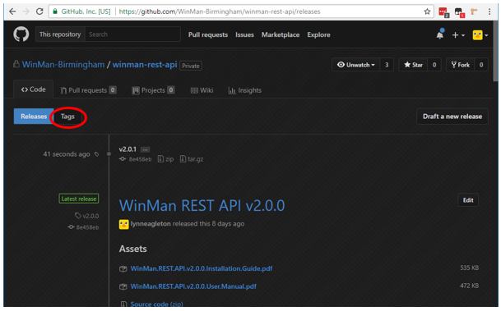
Here you will see a simple list of all tags without their release notes. Click on the Add release notes tab next to your new tag:
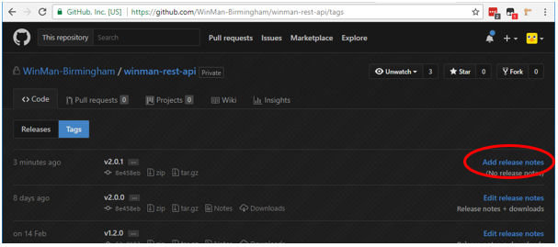
On the next page, enter the title of your release as “WinMan REST API <version>” in the title box and enter your release notes in the large description box. You should also create updated versions of the User Manual and Installation Guide (found in Dropbox) and upload them to your release in the section labelled Attach binaries by dropping them here… (underneath the large description box):
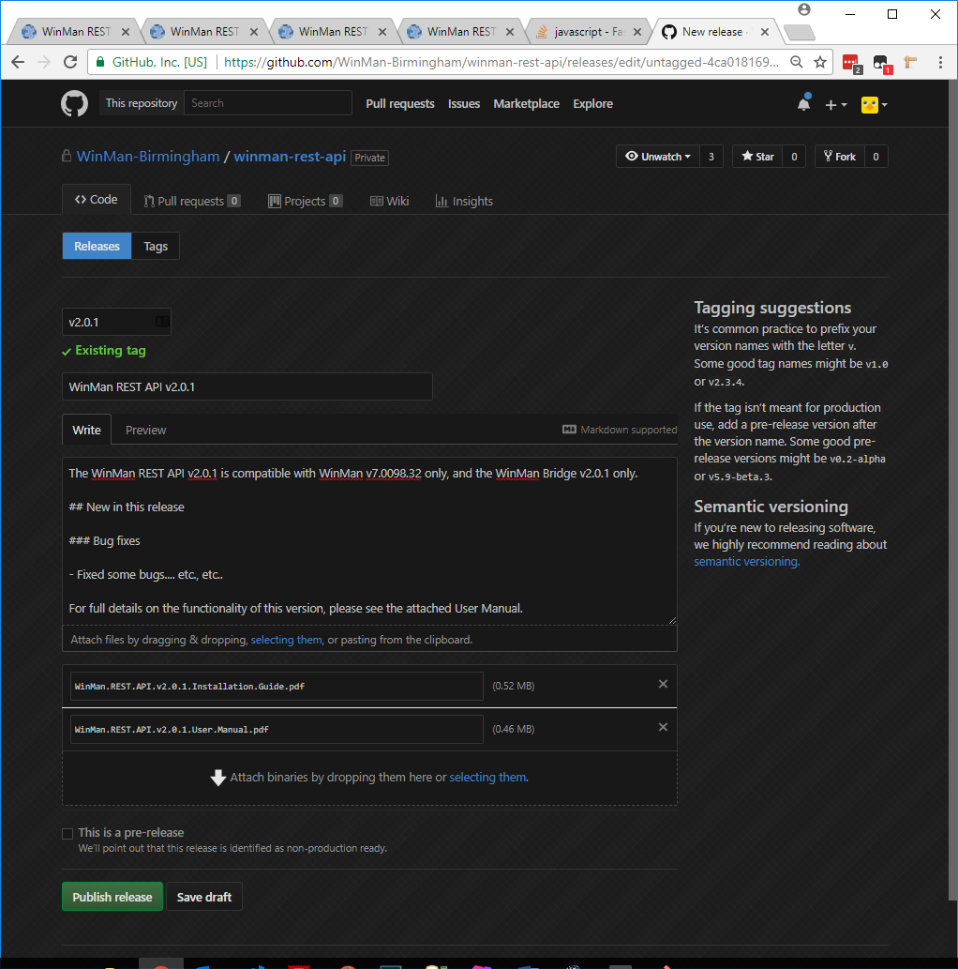
Click the green Publish release button when you are finished. You can also go back and make additional changes to your release notes later on if you need to by clicking the relevant Edit button on the Releases page in GitHub.

Installation for a Customer (Standard API)

Installation on a customer’s server is carried out by WinMan Support, but a member of Development (Birmingham) must provide Support with the compiled API files.
Please note that Support will not necessarily know if a customer has a bespoke version of the API or not. As such, you should check the bespoke repository in GitHub to see if the customer has a branch before generating any files. If the customer does have a branch, you should generate files for the bespoke API instead.
If you receive a task to provide Support with the API files for a particular customer, the task should include the following information:
- The service name. For example, winman-rest. Please keep the name winman in this service name instead of the customer’s name. This service name must be unique on the customer’s server, so if they already have an installation of the API, please make sure it is using a different service name.
- The display name for the service. This is simply a more user-friendly version of the service name which will be visible in the list of Windows services on the customer’s server. For example, WinMan REST API. This name will also be displayed in several places in the API Portal. As such, please keep the name WinMan in this display name instead of the customer’s name. This display name must be unique on the customer’s server, so if they already have an installation of the API, please make sure it is using a different display name.
- SQL server connection information. This should be provided for each database the API will connect to (e.g. both Live and Training).
  - SQL server name. If the API is being installed on the same server as the SQL server, this can be set to localhost.
  - SQL server instance name. For a large proportion of WinMan’s customers, this will not be applicable as the customer uses the default instance.
  - Username. A username which can be used to log on to the SQL Server.
  - Password. The password for the above username.
  - Database name. This will usually be something like Winman or Training.
  - Reports server username. A username which has access to the customer’s WinMan reports server. This is necessary as some of the API’s endpoints return PDFs from the reports server which requires NTLM authentication.
  - Reports server password. The password for the above username.
- The API URL. This will be the DNS entry which was set up by Mike. For example, rest.winman.net. The same URL can be used on the customer’s server for multiple API installations as long as the port number is unique.
- The API port number. This will usually be 3000 for the first installation on the customer’s server, 3001 for the second and so on. This port number must be unique on the customer’s server, so if they already have an installation of the API, please make sure it is using a different port number.
If any of the above information is missing or seems incorrect, please liaise with Support to rectify this. If the information is correct and complete you can continue to generate the files.
Open Git Bash and cd to your WinMan REST API directory:
cd /d "<path to git>\winman-rest-api"
You should replace <path to git> with the file path you used to clone the repository (e.g. D:\git).

Make sure you have the latest release of the API checked out (v2.0.0 at the time of writing this document) and up to date ( git checkout v2.0.0 and git pull if necessary). Next, type the following and press enter.
npm run build
You will now be prompted to answer the same questions you were asked when you installed your development version of the API. Answer the questions with the information which was provided by support. For each question that is presented, you can enter ? if you wish to view a help message. If you accidentally enter the wrong information, you will need to manually edit the generated index.js file in the config/dist folder or re-run the above command and enter the information again.
Once this command has completed, you can zip up the contents of the dist folder within your WinMan REST API repository directory and send this ZIP file to WinMan Support.
If the customer requires an older version of the API for any reason, you can generate the required files in the same way as above, but instead of checking out the latest release, you should checkout the required version. For example, if the customer requires v1.2.0, checkout this version using the following:
git checkout v1.2.0
Each version of the API has its own release notes in GitHub. Simply navigate to the Releases tab in the repository to view them:
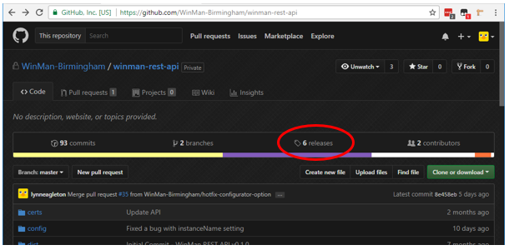
You can also view a list of releases (a.k.a tags) by using the following command in Git Bash:
git tag

Installation for Development (Bespoke API)

Installing the global Node modules
This guide assumes that you have already installed NodeJS v6.11.2 on your PC. Please note that all commands / code snippets in this document are case-sensitive.
If you have not installed any version of the WinMan REST API on your PC before, you will need to install two global Node modules. If you have already installed these two modules, you can skip this step, otherwise, open an elevated command prompt window (right-click and click Run as Administrator), type the following and hit enter.
npm install --global --production windows-build-tools
This command will take approximately 5-10 minutes to complete. After it has completed, type the following and press enter.
npm install --global node-gyp
This command will take approximately 1-2 minutes to complete.

Adding the environment variables

If you have not installed any version the WinMan REST API on your PC before, you will need to create two new environment variables. If you have already done this, you can skip this step, otherwise, open the System Environment Variables window. To do this, click the Windows button in the bottom-left corner of the screen and type environment variables. Click on the result labelled Edit the system environment variables, which will bring up a small properties window. In this window, click the button labelled Environment Variables. You should now see a window similar to the following:

Click the bottom button labelled New… to create a new system environment variable.

There are two variables to create, the first of which defines the location of the Python executable. You should enter the following information and click OK when done:

Variable name: PYTHON
Variable value: C:\Users\<username>\.windows-build-tools\python27\python.exe

You should change <username> to match the user you log on to your PC with, for example lynn.eagleton.SSL.

The second variable defines the mode which NodeJS runs in on your PC. You should enter the following information and click OK when done:

Variable name: NODE_ENV
Variable value: development

Next, you should close and reopen your elevated command prompt window so that the new environment variables take effect.

Cloning the repository
To install a bespoke version of the WinMan REST API, you must first clone the bespoke WinMan REST API repository from GitHub. If you do not have access to this repository, please speak to Stu to request access.
This guide assumes you are using Git Bash for version control operations.
To clone the repository, open a file explorer window, navigate to an appropriate location on your PC (e.g. D:\git), right-click in this window and then click Git Bash Here. This opens the Git Bash application. Type the following and hit enter.
git clone https://github.com/WinMan-Birmingham/bespoke-winman-rest-api.git
You will be prompted for your GitHub username and password. Enter your credentials to continue the clone.
Each WinMan customer who has a bespoke version of the WinMan REST API must have their own branch within the bespoke repository, so you should now checkout or create the relevant branch. To see a list of existing branches, you can use the git branch command.
As an example, this guide will assume you are using the bespoke API for Talking Tables:
git checkout talking-tables
Before you can install the bespoke API, you must copy the standard API files into your bespoke repository directory. If you have not already done so, clone the standard repository by following the instructions in the appropriate section of this document. Once you have done this, checkout the appropriate tag in the standard repository. For example, Talking Tables are currently using version 1.2.0 of the API (correct at time of writing this document), so you should make sure you checkout this version by using git checkout v1.2.0 . Once the appropriate version is checked out, you should copy and paste all of the files from the standard repository into your bespoke repository. When you are asked if you want to overwrite existing files you must click ‘Skip these files’ to make sure the correct .gitignore files remain in place.
After this has been completed, you can return to your elevated command prompt window.

Installing the API

In your elevated command prompt window type the following and press enter.
cd /d "<path to git>\bespoke-winman-rest-api"
You should replace <path to git> with the file path you used to clone the repository (e.g. D:\git).

Next, type the following and press enter.
npm install
This may take 5-10 minutes to complete.

Once this has completed, you must generate your development config file. To do this, type the following and press enter.
npm run develop
You will be prompted for several pieces of information. For each question that is presented, you can enter ? if you wish to view a help message. If you accidentally enter the wrong information, you will need to manually edit the generated index.js file in the config folder or re-run the above command and enter the information again. For development on your local PC using your SQL2016SANDBOX WinMan application, you may wish to use settings like the following.

Service name: bespoke-winman-rest
Service display name: Bespoke WinMan REST API
Live SQL server name: SQL2016SANDBOX
Live SQL server instance name: <leave blank>
Live SQL server username: winman
Live SQL server password: winman
Live SQL server database name: <your DB name>
Live reports server username: <the username you use to log on to your PC>
Live reports server password: <the password you use to log on to your PC. Please note that the password is masked on the screen as you type it and encrypted in your config file, so you don’t need to worry about others seeing it>
Would you like to add a Training system? N
API URL: rest.winman.net
API port: 3001

Please note that the API port number must be different to the API port number you have used for other installations of the API on your PC.

Finally, you must generate the necessary frontend files. To do this, type the following and press enter.
npm run compile
The above command lints and compiles all Sass files into CSS, minifies and obfuscates template files and JavaScript files, and copies these files into the necessary places within your WinMan REST API repository directory.

Adding an entry in your hosts file

To be able to access your API, you must add an entry to your PC’s hosts file. If you have already done this for the standard API you can skip this step, otherwise (or if you wish to use a different API URL), open a text editor like Notepad as an Administrator and open the following file.
C:\Windows\System32\drivers\etc\hosts
Add the following to the bottom of the.
127.0.0.1 rest.winman.net
You should change rest.winman.net to match the API URL you used whilst generating your development config file.

Adding the Windows service

In order for the API to be available all the time, it needs to be run as a Windows service. To set this up, back in your elevated command prompt window, type the following and press enter. Please note that you must run this command from your bespoke WinMan REST API repository directory. cd to the correct directory if necessary (see the first command in the Installing the API section of this document).
node winman-rest --add
If the service is added successfully, you should see a message which says something like Bespoke WinMan REST API service successfully added.

Finally, you can start the service. Type the following and press enter.
net start "<service name>"
You should replace <service name> with the actual service name, e.g. bespoke-winman-rest.
If the service is started successfully, you should see a message which says something like The Bespoke WinMan REST API service was started successfully.

The API is now installed, but before you can access any information, some data must be added within the WinMan application. Instructions on what to add and how to add it can be found in the WinMan REST API v2.0.0 User Manual.

Also, the relevant programs and REST API Scopes in WinMan must be activated. For instructions on how to achieve this, please refer to the Activating the UI Screens and Activating the REST API Scopes sections of this document within the Installation for Development (Standard API) section.

Development (Bespoke API)

Using Git

Creating a new branch
All development work for the Bespoke WinMan REST API must be carried out on your own branch in Git. You must never commit directly to the master branch or a customer’s branch, as this can cause problems for other developers who are also contributing to the project.
In the Bespoke WinMan REST API repository, each customer has their own branch, and the master is not used.
To create your own branch, open Git Bash from within your Bespoke WinMan REST API repository directory and make sure you have the relevant customer’s branch checked out. Use the command git checkout <branch name> if necessary. You will know you have the correct branch checked out if you can see the name of the branch at the end of the file path in Git Bash, for example:
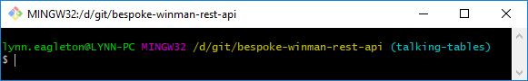
You can also check which branch you’re currently on by issuing the git status command, for example:
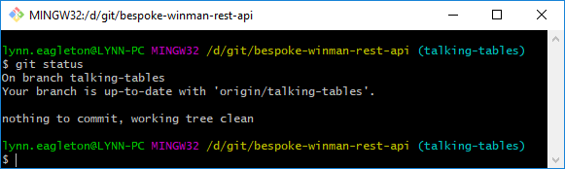
Make sure you have the latest version of the customer’s branch by issuing the following command.
git pull
Next, create your branch by issuing the following command.
git checkout -b <new branch name>
All other instructions regarding the creation of new branches and the creation of commits for the Bespoke WinMan REST API are the same as for the standard API. Please refer to the appropriate sections of this document within the Development (Standard API) section.

Creating pull requests
The process for creating a pull request for the Bespoke WinMan REST API is almost identical to the process for the standard API, so please familiarise yourself with the instructions in the appropriate section of this document. The only difference is that the pull request must specify the customer’s branch as the base branch instead of the master branch:
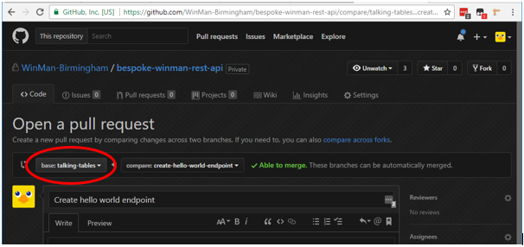
The instructions for reviewing and merging pull requests are the same as for the standard API.

Creating a new endpoint
In order to create a new endpoint for the Bespoke WinMan REST API, or to create a bespoke version of an existing standard endpoint, you can follow the same process as for the standard API. The only difference is the location in which you place your files, and the fact that your stored procedures should start with ‘bsp’ instead of ‘wsp’. If you are creating an entirely new bespoke endpoint (i.e. you are not overriding an existing standard endpoint), your bespoke endpoint file structure should look something like this:
├── routes
│ └── local
│ └── HelloWorld.js
├── sql
│ └── stored_procedures
│ ├── bsp_RestApiHelloWorldSelectJSON.sql
│ └── bsp_RestApiHelloWorldSelectXML.sql
└── views
└── static
└── swagger
└── schema
├── definitions
│ └── local
│ └── HelloWorld.json
└── paths
└── local
└── HelloWorldMessage.json

If you are overriding some functionality of an existing standard endpoint, you only need to create the files in the example structure above which will have different code to the standard versions of the files. For example, if you wish to override a small part of the Sales Orders (POST) standard endpoint and nothing else, the only file you need to create is routes/local/SalesOrders.js .
Please note that any files in local directories take precedence over files in matching core directories. Any code in the matching/overridden core files is completely ignored.

Installation for a Customer (Bespoke API)

Installation on a customer’s server of a bespoke version of the API is largely the same as for the standard version. The only difference is that you must generate the API files for Support from within your bespoke repository, not the standard one.
To do this, you must first copy the files from the desired version of the standard API into your bespoke repository. Remember to click ‘Skip these files’ when you are asked if you want to overwrite existing files. Next, you can run the npm run build command the same as you would for the standard API. All other instructions are the same as for the standard API.
Please note that Support will not necessarily know if a customer has a bespoke version of the API or not. As such, you should check the bespoke repository in GitHub to see if the customer has a branch before generating any files.

Upgrading a Customer (Standard API and Bespoke API)

Upgrading a customer to a more recent version of the API is a simple matter of replacing the API files on their server with the newer files and restarting the Windows service. The upgrade will be performed by WinMan Support, so as a member of Development (Birmingham) you simply need to generate the files and send them to Support.
If the customer is using a standard version of the API, follow the steps in the Installation for a Customer (Standard API) section of this document, making sure you checkout the desired version of the API.
If the customer is using a bespoke version of the API, follow the steps in the Installation for a Customer (Bespoke API) section of this document, making sure you use the core files of the desired version of the standard API as well as your bespoke files.

NPM commands
This section of the guide lists all the npm (Node Package Manager) commands which are specific to the WinMan REST API. These commands allow you to do things like compiling the API codebase, compiling your Sass into CSS and generating your development config file.
To run any of the npm commands successfully, you must run them from within your WinMan REST API repository directory. cd to the correct directory if necessary (see the first command in the Installing the API section of this document).
The same set of commands can be used in both the Standard API and the Bespoke API.

Build
You can invoke the build task by issuing the following command.
npm run build
This command is used for generating the distributable files ready for deployment to a customer’s server. Whilst running this command, you will be prompted to answer the same questions as you were asked whilst generating your development config file. You should answer the questions using the information provided by WinMan Support. Please liaise directly with WinMan Support if any of the information is missing or seems incorrect.
Once this command has completed, you can zip up the contents of the dist folder within your WinMan REST API repository directory and send this ZIP file to WinMan Support.
Please note that you should make sure you checkout the correct version of the repository before running this command, otherwise, any development work that you have in progress will be included in the distributable files. You should checkout the correct version by checking out the relevant tag. For information on which version of the API is compatible with which version of WinMan, please see the release notes in GitHub.

Compile
You can invoke the compile task by issuing the following command.
npm run compile
This command lints and compiles all Sass files into CSS, minifies and obfuscates template files and JavaScript files, and copies these files into the necessary places within your WinMan REST API repository directory.
You should run this command whenever you have made changes to your JavaScript, template or Sass files and want to see the results in your API frontend.

Develop
You can invoke the develop task by issuing the following command.
npm run develop
This command generates a config file for development use. You need to run this command when you first install the API on your PC. You may need to re-run this command if you checkout older versions of the API and then checkout the latest version again. You may also need to re-run this command if you ever need to change your config settings. Alternatively, you can manually edit the index.js file in your config folder.

Sass
You can invoke the sass task by issuing the following command.
npm run sass
This commands lints and compiles your Sass files into CSS and places the generated (minified) CSS file into the correct location in your WinMan REST API repository directory. You may wish to use this command if you have made changes to any of your Sass files (i.e. frontend styling changes) and wish to see the results in your API frontend. Please note that this task handles Sass files only, so if you have also made changes to JavaScript or template files, you should use the compile command instead.

Further reading

- Command line basics: https://www.makeuseof.com/tag/a-beginners-guide-to-the-windows-command-line/
- Vim: https://www.fprintf.net/vimCheatSheet.html
- Git: https://git-scm.com/docs
- NodeJS: https://nodejs.org/en/docs/
- Npm: https://docs.npmjs.com/
- Sass: https://sass-lang.com/documentation/
- WinMan REST API release notes: https://github.com/WinMan-Birmingham/winman-rest-api/releases
- Git: https://git-scm.com/docs
  - Pay particular attention to these commands:
git clone
git status
git pull
git checkout
git add
git commit
git push
git branch
git tag
git rebase
git reset
- Swagger UI: https://swagger.io/swagger-ui/
- Swagger 2.0 specification: https://github.com/OAI/OpenAPI-Specification/blob/master/versions/2.0.md

